METHODOLOGY
2.0 overview
This study employed a data-driven approach to predict the compressive strength of concrete using multiple machine learning algorithms. The methods include data collections, data processing, model training and evaluation, hyperparameters optimization, ensemble learning to enhance prediction power and model interpretability analysis using SHAP and Partial Dependence Display.
2.1 data collection and processing
The dataset was collected from UCI Machine learning repository which is contributed by prof. I-Cheng Yeh. It has 1030 samples and 9 attributes, cement, blast furnace slag, fly ash, water, superplasticizer, coarse aggregate, fine aggregate, age and compressive strength[1]. All the attributes are in kg per meter cube with exception of age and compressive strength which are in days and Megapascal respectively.
The dataset was examined for missing values, duplicate and extreme values. No missing values were found, confirming the dataset’s completeness. However, 25 duplicate records were identified and removed to prevent model bias and overrepresentation of identical samples. Additionally, 94 outliers were detected using the interquartile range (IQR) method and were exclude to minimize their undue influence on model training. These steps improved the overall quality of the dataset and enhanced its suitability for reliable model training.
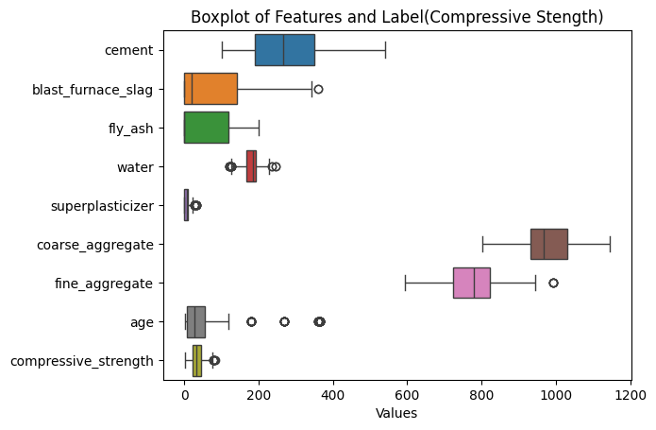

2.2 Machine learning algorithms
The dataset was split into 80% for training and 20% for testing, with a random state of 100 to ensure reproducibility[1]. Hyperparameter tuning was performed on the training set using RandomizedSearchCV with 10 - fold cross validation to identify the optimal configurations.
Seven machine learning algorithms were evaluated for predicting concrete compressive strength. Five individual models; AdaBoost, XGBoost, LightGBM, Random Forest, and CatBoost; while the remaining two were ensemble methods: Voting and Stacking, which combine predictions from multiple models. The Voting ensemble comprised XGBoost, LightGBM and CatBoost whereas the stacking ensemble consisted of XGBoost, CatBoost, Random Forest and RidgeCV as a meta learner. Both ensembles were developed based on the best-performing models obtained after hyperparameter tuning.

2.2.1 AdaBoost Machine Learning Algorithm
AdaBoost is a short form of Adaptive Boosting, is an ensemble machine learning algorithm that combines multiple weak learners to form a strong classifier. The algorithm places greater emphasis on training samples that are challenging to classify by updating their weights in successive iterations, thereby enhancing the overall prediction accuracy of the model [3].
In this research, AdaBoost initializes all training samples with equal weights. A decision tree is trained as the weak learner, prediction errors are evaluated, and sample weights are updated accordingly. This process is repeated for a specified number of iterations ranging from 50 to 300, after which the final prediction is obtained through a weighted voting scheme of all weak learners.
For each weak learner, the following steps are performed:
Error of each sample:
$$e_{i}^{\left(t\right)}= \frac{|y_{i}- \hat{y_{i}^{(t)}|}}{max⁡|y- \hat{y^{\left(t\right)}}} 1$$
Weighted error of the weak learner:
$$£_{t}=\sum{w_{i}e_{i}^{(t)} 2}$$
Model weight parameter:
$$β_{t}= \frac{£_{t}}{1- £_{t}} 3$$
Weight of the weak learner:
$$α_{t }= \ln{(\frac{1}{β_{t}})} 4$$

Final Prediction:
$$\hat{ y}\left(x\right)=\frac{\sum_{t=1}^{T}{α_{t}h_{t}(x)}}{\sum_{t=1}^{T}{α_{t}}} 5$$

2.2.2 Random Forest Algorithm
Random forest algorithm is an example of integrated machine learning methods that utilizes multiple decision trees to make predictions. Each tree is trained on a different subset of the training data that are generated through random sampling and final prediction is obtained by averaging their results.[1][4]
For this research, four critical parameters were set for the model to run, these are “n_estimators”, “max_depth”, “min_samples_split” and “min_sample_leaf”. Where n_estimators is number of trees for this research which is set to range of 100 to 300 trees. These parameters are the one use for model turning.
$$f\left(x\right)= \sum_{m=1}^{M}{\frac{1}{m}f_{m}(x)} 6$$
Where, fm is considered m^{th} trees
2.2.3 XGBoost Algorithms
XGBoost (eXtreme Gradient Boosting) is a powerful ensemble machine learning algorithm based on gradient boosting of decision trees. It is specifically designed for high performance, scalability, and regularization. The algorithm improves predictive accuracy by iteratively learning from previous errors (residuals) and minimizing a specified loss function using gradient descent. In XGBoost, decision trees are trained sequentially, where each new tree is fitted to the residuals of the preceding trees. The algorithm employs data resampling and tree-based partitioning to construct weak learners, while built-in regularization techniques help control model complexity and prevent overfitting [3].

